Qingdao Shengxin Materialware Co., Ltd
ADD:Wangtai,Huangdao, Qingdao,Shandong,China
Tel: 0086-532-83136379
Mobile:0086-15963239863
Web:www.qdshengxin.com.com
Email:linda@sxequipment.com

Pig Farm Equipment Price List 2019
- Double Farrowing Crate 4.4x2.4m USD855.0/set
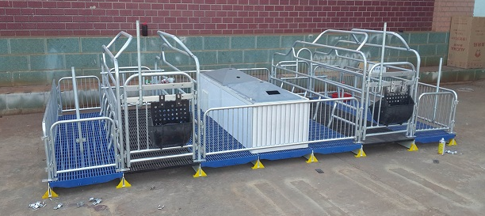
Cast Iron Floor:700x700mm 6pcs
300x700mm 2pcs
Plastic floor:600x600mm 20pcs
Fiberglass beam:2.4m 8pcs
Bracket: 16pcs
Cast iron feeder 2pcs
Warm house 2pcs
2.Double Farrowing crate 3.8x2.4m USD825.0/set
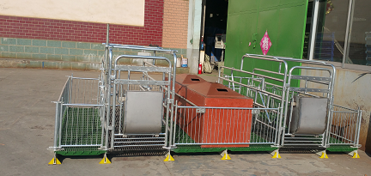
Cast Iron Floor:1200x700mm 4pcs
Plastic floor:500x600mm 8pcs
700x600mm 8pcs
Fiberglass beam:2.4m 7pcs
Bracket: 14pcs
SS feeder 2pcs
Warm house 2pcs

- Double Nursery Crate 3.6x2.4m USD499.0/pc
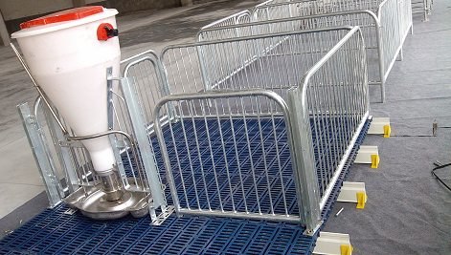
Plastic floor:600x600mm 24pcs
Fiberglass beam 2.4m 7pcs
Bracket 14pcs
Dry and wet feeder 1pc
3.Nursery Crate:2.4x1.8m USD205.0/pc
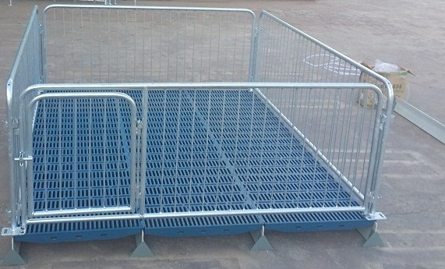
Plastic floor:600x600mm 12pcs
Fiberglass beam 2.4m 4pcs
Bracket 8pcs

4. Boar Stall 3.5x3x1.2m USD258.0/set
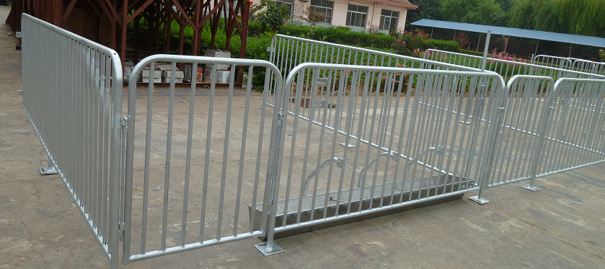
One side fence, one front fence with front door
SS long feeder 2m
5. Gestation Crate 2200x600mm USD75.0/pig(one side, one front and one rear fence)
Feeder:USD17.0/pc
